

Official Newsletter of the Heartland CRLA Chapter: IA, MO, KS, OK, NE

December 2016

Heartland President’s Note

2016 CRLA Board

President  
Jack Trammell

[jtrammel@rmc.edu](mailto:jtrammel@rmc.edu)

President Elect  
Victoria Appatova

[victoria.appatova@uc.edu](mailto:victoria.appatova@uc.edu)

Past President

Dorothy Briggs

[dabriggs@email.arizona.edu](mailto:dabriggs@email.arizona.edu)

Secretary  
Kathy Stein

[kstein@sulross.edu](mailto:kstein@sulross.edu)

Treasurer  
Maureen DuPont

[mdupont@csusm.edu](mailto:mdupont@csusm.edu)

Certifications Director  
Page Keller

[kellerp@cofc.edu](mailto:kellerp@cofc.edu)

Professional Development Director  
Suzanne McCarthy

[mccarthys@centenarycollege.edu](mailto:mccarthys@centenarycollege.edu)

Public Relations Director  
Marissa Loon

[marissa.loon@nichols.edu](mailto:marissa.loon@nichols.edu)

Publications Director  
Sonya L. Armstrong

[sarmstrong@niu.edu](mailto:sarmstrong@niu.edu)

Hello, Heartland colleagues. I am excited to serve as the Heartland CRLA President this year. A month ago, I accepted a position as the Student Success Manager at Longview Community College, in Lee’s Summit, MO. My colleagues here have been quite welcoming and are doing great things for our students relative to academic success. I am looking forward to learning and sharing best practices with everyone at our conference this spring.

Our conference will take place April 6-7 in Kansas City, MO. Sara Keenan, President-Elect, selected a wonderful venue for us at the Country Club Plaza and is working to organize the conference. Information relative to the call to conference will be coming in early January. Think about possible topics for your presentations.

I want to say a special thank you to Jeff Merritt and Linda Creason for upgrading our website for our members. At our chapter business meeting in Louisville, Kentucky it was decided that we should improve the registration process for our members. We now have a much improved method for payment and registration confirmation. Members can pay via PayPal or via check.

Looking forward to seeing everyone soon!

*Sincerely,*

*Joe Barnhill, President of the Heartland Chapter of the College Reading and Learning Association*

1

**Heartland Chapter Board**

**President:**

Joe Barnhill

[joe.barnhill@mcckc.edu](mailto:kmccoske@butlercc.edu)

**President-Elect:**

Sara Keenan

[sara.keenan@rockhurst.edu](mailto:sara.keenan@rockhurst.edu)

**Past-President:**

Kathy McCoskey

[kcccoske@butlercc.edu](mailto:kcccoske@butlercc.edu)

**Secretary:**

Kimberly Courtwright

[Courtwright@ucmo.edu](mailto:Courtwright@ucmo.edu)

**Treasurer:**

Linda Creason

[lcreason@jccc.edu](mailto:lcreason@jccc.edu)

**Membership Coordinator:**

Shari Clevenger

[clevengs@nsuok.edu](mailto:clevengs@nsuok.edu)

**Webmaster**

Jeff Merritt

[jmerritt@jccc.edu](mailto:jmerritt@jccc.edu)

Register for our

CRLA Heartland Chapter Spring

Conference

April 6-7, 2017

*“Communicating a Growth Mindset”*

Location and Lodging: Sheraton Suites Country Club Plaza

770 W 4th Street, Kansas City, MO 64112.

<http://www.sheratoncountryclubplaza.com/>

Walking distance to many shops and restaurants, rooms are all suites with separate bedrooms and living space, microwave and fridge! A reduced rate of $115 a night plus tax.

Visit our Heartland CRLA website for additional details about the Sheraton and the [conference](http://media.wix.com/ugd/4be8ea_9639cc3b07c6442f86a68239a599d7c9.pdf): <http://heartlandcrla.wix.com/heartlandcrla>

**Heartland CRLA Registration fee:**

**$115.00** for professionals

**$ 50.00** for full-time students

*Fee includes* $5 Heartland Chapter membership, conference sessions, materials, lunches and snacks.

To register for the conference go to our [website](http://heartlandcrla.wixsite.com/heartlandcrla)! [Click on the online registration page](http://heartlandcrla.wixsite.com/heartlandcrla/shop) and follow the directions. Complete the registration and then you can pay electronically via PayPal or choose to pay by check.

Registration deadline is March 27th.

*Throughout the conference, we will have drawings, so please consider bringing your new or gently used books and gifts!*

April ’17 Conference Highlights You Don’t Want to Miss!

* Dr. Laura Janusik, Associate Professor of Communication at Rockhurst University, will be our Keynote Speaker at Thursday’s luncheon. She is subject matter expert in listening, communication, metacognition and serves as an editor for many journals relative to listening and communication.
* Many concurrent sessions by outstanding colleagues
* Chapter Business Meeting and election of new president-elect
* Time to meet and share with colleagues
* An interpretive dance by Joe Barnhill and Diana Rottinghaus reflecting the struggles of two late 19th century Missouri tutors.
* As always, Heartland CRLA friendliness & hospitality!

***Photos from the CRLA International Conference in Louisville, Kentucky November 2016:***

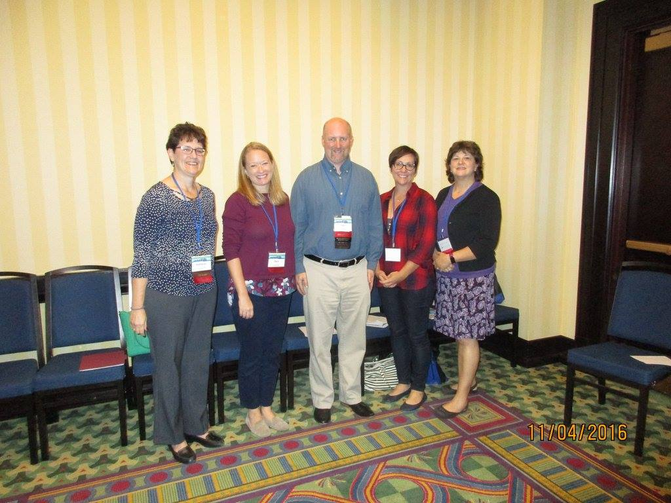

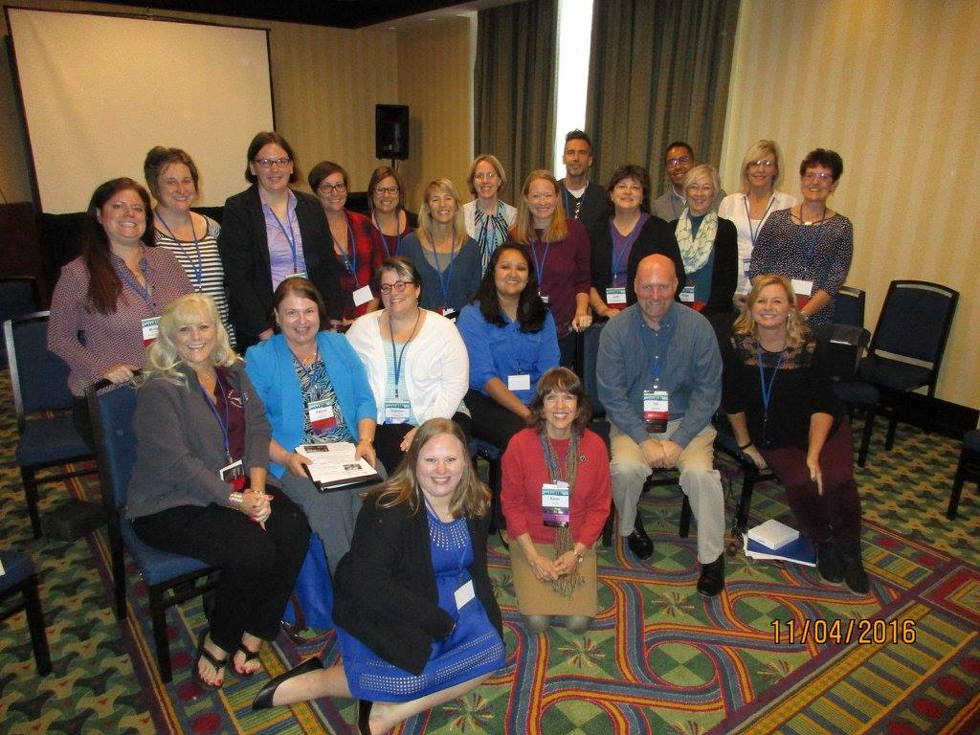

**Heartland Chapter Leadership Opportunities**

e 6

As we approach our Heartland Conference in April, please consider a leadership position as the **President-Elect.** The positions is important to the organization and provide valuable leadership experience. The duties are listed in the Bylaws on our website. If you are interested in a leadership position or wish to nominate someone, contact Past-President: **Katheryn (Kathy) McCoskey,** [**kmccoske@butler.edu**](mailto:kmccoske@butler.edu)

Also, be sure “like” our Facebook page!

[**https://www.facebook.com/HeartlandCRLA**](https://www.facebook.com/HeartlandCRLA)