

Official Newsletter of the Heartland CRLA Chapter: IA, MO, KS, OK, NE

March 2016

Heartland President’s Note

Greetings! It is my honor to serve as Heartland CRLA President this year. Both my college and I have benefitted so much over the years from the wealth of knowledge and generosity of Heartland colleagues; I will always be grateful for the information and encouragement I have received that have helped me growth professionally and personally. Whether you are new or a long-time Heartland CRLA colleague, I urge you to participate in this jewel of an organization and to join us for our spring conference April 14 – 15 in Overland Park, KS. Joe Barnhill, President-Elect, is in the midst of planning a terrific conference for us! See this newsletter for more details about registration.

Finally, I want to share with you some book titles that have made an impact on my instruction and thinking in recent years. I hope this lists is helpful to you! They are:

* *Teaching Unprepared Students: Strategies for Promoting Success & Retention in Higher Education* by Kathleen Gabriel
* *Multiple Pathways to the Student Brain: Energizing and Enhancing Instruction* by Janet Zadina
* *Mindset: The Psychology of Success* by Carol Dweck
* *We’re Born to Learn: Using the Brain’s Natural Process to Create Today’s Curriculum* by Dr. Rita Smilkstein

I hope to see you soon at the conference, looking forward to more sharing & growing!

*Sincerely, Katheryn (Kathy) McCoskey, President*

2016 CRLA Board

President  
Dorothy Briggs

[dabriggs@email.arizona.edu](mailto:dabriggs@email.arizona.edu)

President Elect  
Jack Trammell

[jtrammel@rmc.edu](mailto:woodruff@hawaii.edu)

Past President

Rosemarie Woodruff

[woodruff@hawaii.edu](mailto:dabriggs@email.arizona.edu)

Secretary  
Kathy Stein

[kstein@sulross.edu](mailto:kstein@sulross.edu)

Treasurer  
Maureen DuPont

[mdupont@csusm.edu](mailto:mdupont@csusm.edu)

Certifications Director  
Page Keller

[kellerp@cofc.edu](mailto:kellerp@cofc.edu)

Professional Development Director  
Suzanne McCarthy

[mccarthys@centenarycollege.edu](mailto:mccarthys@centenarycollege.edu)

Public Relations Director  
Marissa Loon

[marissa.loon@nichols.edu](mailto:marissa.loon@nichols.edu)

Publications Director  
Sonya L. Armstrong

[sarmstrong@niu.edu](mailto:sarmstrong@niu.edu)

1

Register for our

CRLA Heartland Chapter Spring

Conference

April 14 – 15, 2016

*“Teaching and Learning in the*

*Digital Age”*

by April 1!

Location: Baker University--Overland Park Campus

7301 College Boulevard, located directly off I-435 at the cross streets of College and Metcalf.

This is a lovely professional venue in mid-town Overland Park with plenty of shopping and restaurants nearby!

Lodging: Pear Tree Inn—Overland Park.

10951 Metcalf (located .4 miles from conference site)

913-451-0200

**Heartland CRLA Registration fee:**

**$100** for professionals

**$ 50.00** for full-time students

*Fee includes* $5 Heartland Chapter membership, conference sessions, materials, lunches and snacks.

**Make checks payable to: Heartland Chapter CRLA**

**Mail to:** Linda Creason, Treasurer, (Box 31), Johnson County Community College, 12345 College Blvd. Overland Park, KS 66210

Or register electronically at our website! <http://heartlandcrla.wix.com/heartlandcrla>

*Throughout the conference, we will have drawings, so please consider bringing your new or gently used books and gifts!*

**Heartland Chapter Board**

**President:**

Kathy McCoskey

[kmccoske@butlercc.edu](mailto:kmccoske@butlercc.edu)

**President-Elect:**

Joe Barnhill

[joe.barnhill@avila.edu](mailto:joe.barnhill@avila.edu)

**Past-President:**

Christy Cutshaw

[cutshaw@allencc.edu](mailto:cutshaw@allencc.edu)

**Secretary:**

Lisa Parra

[lparra@jccc.edu](mailto:lparra@jccc.edu)

**Treasurer:**

Linda Creason

[lcreason@jccc.edu](mailto:lcreason@jccc.edu)

**Membership Coordinator:**

Shari Clevenger

[clevengs@nsuok.edu](mailto:clevengs@nsuok.edu)

**Webmaster**

Jeff Merritt

[jmerritt@jccc.edu](mailto:jmerritt@jccc.edu)

April ’16 Conference Highlights You Don’t Want to Miss!

* Dr. Holly Henry, Learning Architect, Avila University, will be our Keynote Speaker at Thursday’s luncheon. She is subject matter expert in digital product design, on campus courses, and learning theories.
* Ten concurrent sessions by outstanding colleagues
* Session by Accuplacer Representative Kathie Montognese
* Chapter Business Meeting and election of new president-elect and secretary
* Time to meet and share with colleagues
* As always, Heartland CRLA friendliness & hospitality!

***Photos from our April ’15 Conference:***

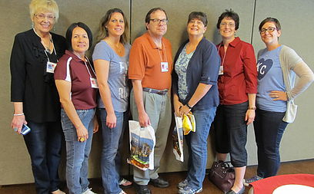

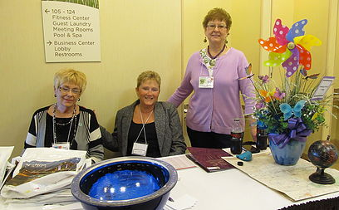

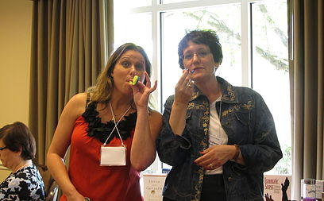

**Heartland Chapter Leadership Opportunities**

e 6

As we approach our Heartland Conference in April, please consider a leadership position as either **President-Elect** or **Secretary.** Both positions are very important to the organization and provide valuable leadership experience. The duties are listed in the Bylaws on our website. If you are interested in a leadership position or wish to nominate someone, contact Past-President: **Christy Cutshaw,** [**cutshaw@allencc.edu**](mailto:cutshaw@allencc.edu)

Also, be sure “like” our Facebook page!

[**https://www.facebook.com/HeartlandCRLA**](https://www.facebook.com/HeartlandCRLA)